**Book conventions**

**Order of operations**

**PEMDAS**: parentheses, exponents, multiplication, division, addition, and subtraction

**Expressing dependent and independent variables in a function**

You can use *y = 2x + 1* or *f(x) = 2x + 1* to express the dependent variable *y* as a function of *x*.

If you have *two independent variables* you write the function like *f(x, y) = 2x + 3y*. In this function two independent variables *x* and *y* and one dependent variable the output of *f(x, y)*. The graph of this function will be plotted on three dimensions to produce a plane of values rather than a line.

**Cartesian plane, x-y plane, coordinate plane**

When we plot on a two-dimensional plane with two number lines (one for each variable) it is known as a *Cartesian plane*, *x-y plane*, or *coordinate plane*. По-русски: *прямоугольная система координат* или *Декартова система*. We trace a given x-value and then look up the corresponding y-value, and plot the intersections

as a line.

Example of a Cartesian plane:

Notice that due to the nature of real numbers (or decimals, if you prefer), there are an infinite number of x values. This is why when we plot the function f(x) we get a continuous line with no breaks in it. There are an infinite number of points on that line, or any part of that line.

**Straight-line function / straight-line graph**

This is a straight-line *f(x) = 2x + 1*:

**Parabola function / parabola graph**

This is a parabola *f(x) = x2 + 1*:

It is continuous but not linear. It does not produce values in a straight line. When a function is continuous but curvy, rather than linear and straight, we call it a *curvilinear function*.

**Summation symbol sigma Σ**

If I want to iterate the numbers 1 through 5, multiply each by 2, and sum them, here is how I would express that using a summation

**Exponents**

23 2 is the base and 3 is the exponent (number of times 2 should be multiplied by 2: 2 * 2 * 2)

When we multiply exponents together with the same base, we simply add the exponents, which is known as the *product rule*:



Division:

**Roots**

A  asks “What number multiplied by itself will give me 4?” which of course is 2. Note here that 41/2 is the same as 4:

41/2 =  = 2

Cubed roots are similar to square roots, but they seek a number multiplied by itself three times to give a result. A cubed root of 8 is expressed as  and asks “What number multiplied by itself three times gives me 8?” This number would be 2 because 2 * 2 * 2 = 8.

power rule

**Logarithms *log()***

A logarithm is a math function that finds a power for a specific number and base.

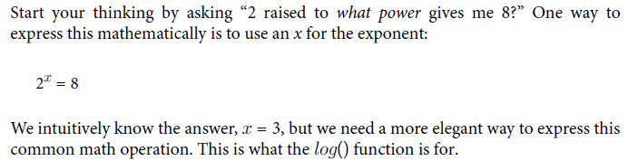



Algebraically speaking, this is a way of isolating the *x*, which is important to solve for *x*.

**Properties for exponents and logarithms**

**Natural logarithms *log() ln()***

When we use *e* as our base for a logarithm, we call it a *natural logarithm*.



However, in Python, a natural logarithm is specified by the log() function. As discussed earlier, the default base for the log() function is *e*. Just leave the second argument for the base empty and it will default to using *e* as the base

**Function that approaches 0 but never reaches 0 *lim***

**Derivatives**



**Partial derivatives**

**The chain rule**

Finding the derivative of *z* with respect to *x*:

This is the chain rule, which says that for a given function *y* (with input variable *x*) composed into another function *z* (with input variable *y*), we can find the derivative of *z* with respect to *x* by multiplying the two respective derivatives together:

The chain rule is a key part of training a neural network with the proper weights and biases. Rather than untangle the derivative of each node in a nested onion fashion, we can multiply the derivatives across each node instead, which is mathematically a lot easier.

**Integrals**

The opposite of a derivative is an integral, which finds the area under the curve for a given range.

Packing rectangles under a curve to approximate area:

**Riemann sums**

Khan Academy has a great [article](https://www.khanacademy.org/math/ap-calculus-ab/ab-integration-new/ab-6-3/a/definite-integral-as-the-limit-of-a-riemann-sum) explaining how to use limits for Reimann Sums.

**Probability**

Probability is how strongly we believe an event will happen, often expressed as a percentage.

**Probability** is about quantifying predictions of events yet to happen, whereas **likelihood** is measuring the frequency of events that already occurred. In statistics and machine learning, we often use **likelihood** (the past) in the form of data to predict **probability** (the future).

Convert probability into odds:

Probability is purely theoretical of how likely an event is to happen and does not require data. Statistics, on the other hand, cannot exist without data and uses it to discover probability and provides tools to describe data.

Think of predicting the outcome of rolling a 4 on a die (that’s the singular of dice). Approaching the problem with a pure probability mindset, one simply says there are six sides on a die. We assume each side is equally likely, so the probability of getting a 4 is 1/6, or 16.666%. However, a zealous statistician might say, “No! We need to roll the die to get data. If we can get 30 rolls or more, and the more rolls we do the better, only then will we have data to determine the probability of getting a 4.” This approach may seem silly if we assume the die is fair, but what if it’s not? If that’s the case, collecting data is the only way to discover the probability of rolling a 4.

**Marginal probability**

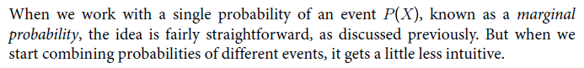

**Joint probability**

**Union probability**

**Conditional Probability and Bayes’ Theorem**

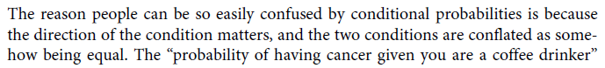

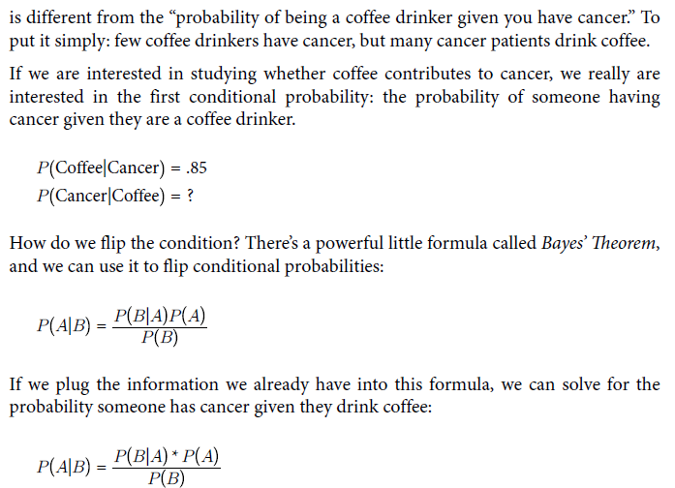

**Joint and union conditional probabilities**

**Binomial Distribution**

Binomial distribution measures how likely *k* successes can happen out of *n* trials given *p* probability. Visually it looks like:

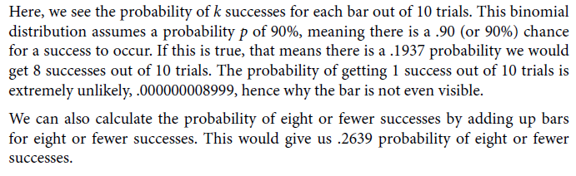

**Beta T-Distribution**

